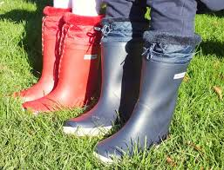

**Language Class**

**Spring 1**

Happy, successful, curious communicators

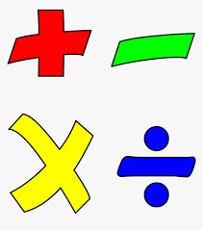

**Maths -Y2**

Week 1: Multiplication and division

Week 2: Multiplication and division

Week 3: Multiplication and division

Week 4: Statistics

Week 5: Statistics

Week 6: Properties of shape

Week 7: Time

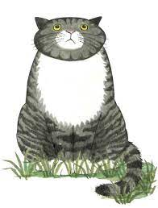

**Writing**

The children in Language Class will complete all of their writing as part of the Read, Write, Inc programme. This is a daily programme that involves phonics, writing and spelling of words appropriate to the stage of learning.

Handwriting, using a cursive writing style is also an essential part of daily writing activities.

**Maths -Y1**

Week 1: Addition and subtraction to 20

Week 2: Addition and subtraction to 20

Week 3: Addition and subtraction to 20

Week 4: Length and height

Week 5: Length and height

Week 6: Place value to 50

Week 7: Place value to 50

**Speech and Language**

All of the children have individual speech and language targets determined by the Mrs Williams, speech therapist. Each child will have focus therapy sessions Tuesday – Friday where they will work specifically on their targets.

Each day there will be 30 minutes of whole class speech and language activities, either as 2 x 15 mins or as one long session. Whole class activities include working on;

* Listening to, giving or following instructions
* Building vocabulary
* Building sentences for speech
* Turn taking and the conventions of conversation
* Pronouns, prepositions, verbs



**Forest School (Monday)**

All pupils to arrive in leggings / jogging trousers, school polo shirt and jumper plus a waterproof coat (with hood) and wellies in a bag to change into. Warm hat and gloves optional in cooler weather.

Week 2: Making bird feeders

Week 3: Mapwork

Week 4: Heads and tails

Week 5: Length - measuring and comparing

Week 6: Walk to Dothill ponds

Week 7: Valentine crafts

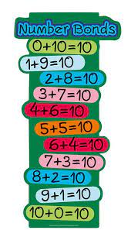

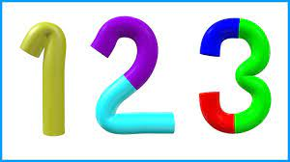



**Reading**

Week 1: Mog and the V.E. T - *To explain clearly their understanding of what is read to them.*

Week 2: Mog’s bad thing - *To discuss the significance of the title and events.*

Week 3: Mog in the dark - *To discuss word meanings and link new meanings to words already known.*

Week 4: - Mog the forgetful cat- *To discuss word meanings and link new meanings to words already known.*

Week 5: Mog’s Christmas -*To listen to and discuss a range of stories at a level beyond that which they can read independently.*

Week 6: Mog and bunny-*To discuss the significance of the title and events.*

Week 7: Judith Kerr- *To listen to and discuss*

*non-fiction at a level beyond that which they*

*can read independently.*

**Maths -Reception**

Week 1: Alive in 5

Week 2: Alive in 5 / capacity

Week 3: Mass

Week 4: Length and height

Week 5: 6, 7 and 8

Week 6: 6, 7 and 8

Week 7: Building 9 and 10.