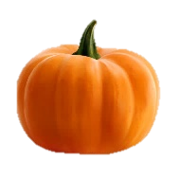

**Communication, Language and Literacy**

* Begin to listen in small group situation when of interest.
* Play with sounds songs and rhymes
* Listen to a short story in a small group situation

**Physical Development**

**Moving and handling**

* Manipulate a ribbon or paintbrush in one hand
* Go up steps or stair or climb apparatus using alternate feet
* Explore scissors and other tools e.g. hammers, rolling pins, hole punch
* Move body during letterjoin gross motor movement sessions

**Health and self-care**

* Use toilet independently and wash hands
* Understand need for clean hands
* Use a knife to spread
* Oral health awareness – importance of brushing teeth. Use resources on Oral Health Foundation

**Personal, Social and Emotional Development**

**Making relationships**

* Begin to build constructive and respectful relationships
* Speaking to other children and adults within the class.
* Make new friends
* Proactive in seeking adult support.
* Know and begin to follow the class rules.

**Sense of self**

* Separating from my main carer
* Recognise that they belong to the class community
* Helping to care for the environment

**Understanding emotions**

* Manage own needs
* Begin to manage own belongings.
* Express own feelings

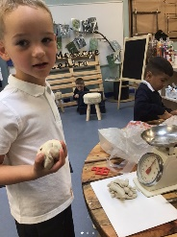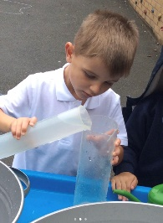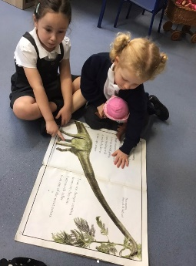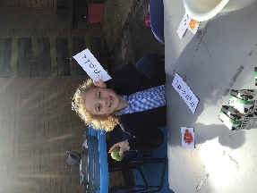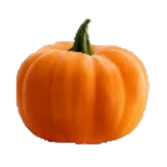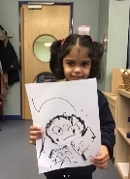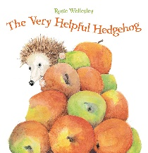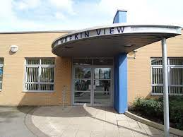

**Mathematics**

**Comparison**

* Recognise numbers of personal significance.

**Counting**

* Enjoys reciting some numbers in order (to 10).
* Begins to order numbers to 5.

**Cardinality**

* Begins to match numeral with group of items to show how much is there (to 5).
* Subitise to 2/3.
* Counts up to 5 objects from a larger group.

**Composition**

* Shows awareness that numbers are made up of smaller numbers.
* In practical activities, adds one and subtracts one with numbers to 10

**Measure**

* Is beginning to order and sequence events using everyday language related to time.
* Discuss and compare length, weight and capacity.
* Introduced to measuring tools in everyday experiences and play.

**Spatial Awareness**

* Use shapes and objects to create models.

**Shape**

* Uses informal language and analogies to describe shape.

**Pattern**

* Spots patterns in the environment, beginning to identify the pattern “rule”

**Reception: Autumn 1**

**‘Explorer of my World’**



**Expressive Arts and Design**

* To recognise different types of materials used for building structures, e.g. wooden blocks, playdough, duplo blocks.
* Begin to use scissors correctly and safely, with support.
* Construct and join modelling items together using scissor and masking tape.
* To enjoy a range of malleable media such as play dough and salt dough.
* To know the names of and draw with a variety of media – pencils, chalk, sticks and mud/sand.

Enjoy using a variety of tools including different size/ thickness brushes and tools i.e. sponge brushes, fingers, twigs. (Art)

Recognise and name the primary colours being used. (Art)

Begin to recall colour mixing knowledge. (Art)

**Exciting Experiences**

Explore the school site

**Literacy**

**Reading**

* Aware of how stories are structured.
* Enjoys an increasing range of print, both fiction and non fiction.

**Phonics**

* Recognises own name.
* Hears and says initial sounds.
* RWI Groups – All Set 1 sounds taught.
* Continues a rhyming string.
* Identifies alliteration.

**Writing**

* Name writing.
* Introduction to cursive letter formation for all Set 1 sounds.
* Gives meaning to the marks they make as they
* draw, write, paint and type using a keyboard or

touch-screen technology.

**Understanding of the World**

People, culture and communities

* To be able to name different places that they visit within school.
* To know that our family and adults within school help us
* To begin to understand a simple map in terms of showing your location.
* To draw simple maps of their immediate environment, including inside the classroom and the outside learning area.

The natural world

* To understand how actions/ behaviour can affect the environment.
* Talk about members of their immediate family and community.

Past and present.

* Sequence photographs from different parts of their life. Match objects to people of different ages.
* Talk about past and present events in their own life and that of their family

Technology

* To create basic commands to move a variety of programmable toys

**Texts of the Term**

In my heart – Jo Witek

This is Me’ by Jamie Lee Curtis and Laura Cornell

The Everywhere Bear’ by Julia Donaldson

‘Charlie and Lola – I am too small for school!’

Jack and the Bean Stalk  
Jellybeans for Giants (George's Amazing Adventures) by Adam Guillian and Charlotte Guillian

Thumberlina  
Room on the broom by Julia Donaldson