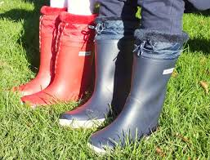

**Language Class**

**Autumn 1**

**Speech and Language**

All of the children have individual speech and language targets determined by the Mrs Williams, speech therapist. Each child will have focus therapy sessions Tuesday – Friday where they will work specifically on their targets.

Each day there will be 30 minutes of whole class speech and language activities, either as 2 x 15 mins or as one long session. Whole class activities include working on;

* Listening to, giving or following instructions
* Building vocabulary
* Building sentences for speech
* Turn taking and the conventions of conversation
* Pronouns, prepositions, verbs



**Forest School (Monday)**

All pupils to arrive in leggings / jogging trousers, school polo shirt and jumper plus a waterproof coat (with hood) and wellies in a bag to change into. Warm hat and gloves optional in cooler weather.

Week 2: Autumn – signs in the school grounds. Apple trees.

Week 3: Colours in the environment.

Week 4: Tall and small.

Week 5: Bridges (linked to drawbridges, Ironbridge)

Week 6: Shape in the environment.

Week 7: What’s the time Mr Wolf?

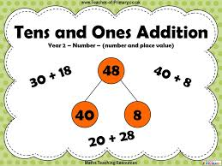

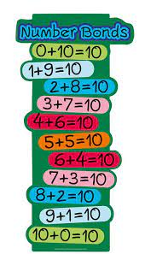

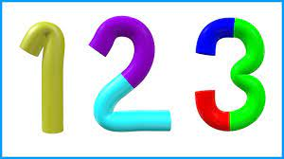



**Writing**

The children in Language Class will complete all of their writing as part of the Read, Write, Inc programme. This is a daily programme that involves phonics, writing and spelling of words appropriate to the stage of learning.

Handwriting, using a cursive writing style is also an essential part of daily writing activities.

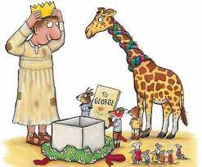

**Reading**

Week 1: The Smartest Giant in Town - To retell well known stories such as fairy tales and traditional stories.

Week 2: Jack and the Bean Pie - To make inferences from the text based on what is said and done.

Week 3: Tom Thumb - To explain clearly their understanding of what is read to them.

Week 4: The Ironbridge Ogre - To check the text makes sense as I read

Week 5: Peggy’s Amazing Ironbridge adventure - To discuss word meanings and link new meanings to words already known.

Week 6: The Wellington Cobbler and the Wrekin Giant - To predict what might happen from what has been read so far

Week 7: Katie and the Beanstalk - To discuss word meanings and link new meanings to words already known.

**Maths -Reception**

Week 1: Baseline assessment

Week 2: Baseline assessment

Week 3: Matching and sorting

Week 4: Comparing amounts, Compare size, mass and capacity

Week 5: Exploring pattern

Week 6: Numbers 1, 2, 3

Week 7: Numbers 1, 2, 3

**Maths -Y2**

Week 1: Place value (within 100)

Week 2: Place value (within 100)

Week 3: Place value (Tens and ones whole part model)

Week 4: Addition and subtraction (within 20)

Week 5: Adding and subtracting one and tens

Week 6: Mock Y2 SATS

Week 7: Time

**Maths -Y1**

Week 1: Place value (within 10)

Week 2: Place value (within 10)

Week 3: Properties of shape

Week 4: Addition and subtraction (within 10)

Week 5: Addition and subtraction (within 10)

Week 6: Addition and subtraction (within 10)

Week 7: Time