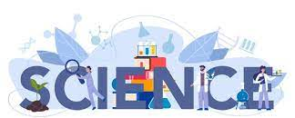

Week 1 | Week 2 | Week 3 | Week 4
To learn that humans need the right types of nutrition, and they cannot make their own food; they get nutrition from what they eat (learn about a balanced diet and sort foods into different groups).  To gathering, record, classify and present data in a variety of ways to help in answering questions. | To learn that animals need the right types and amounts of nutrition. | To learn that humans need the right types and amounts of nutrition. | Do healthier foods (such as apples) provide us with more energy than a chocolate bar?  To learn that humans get nutrition from what they eat  To set up simple practical enquiries, comparative and fair tests.
Week 5 | Week 6 | 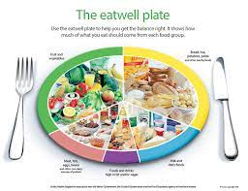  .
To identify that human and some other animals, have skeletons and muscles for support, protection and movement (name some common bones). | Can people with longer legs jump higher?  To identify that human and some other animals, have skeletons and muscles for support, protection and movement.
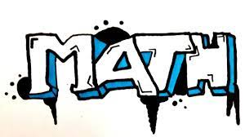

Week 1 | Week 2 | Week 3 | Week 4
~Represent numbers to 100  ~10s and ones using addition ~Hundreds  ~Represent numbers to 1,000 | ~Represent number to 1,000 ~100s,10s and 1s  ~Number line to 100 &Number line to 1,000  ~Find 1, 10, 100 more or less than a given number | ~ Practical activity finding 1,10, 100 more or less.  ~Compare objects to 1,000 & Compare numbers to 1,000  ~order numbers  ~ count in 50s  ~ Assessment for Topic | ~Add and subtract multiples of 100 & Add and subtract 1s  ~ Add and subtract 3-digit and 1-digit numbers – not crossing 10  ~ Add a 2-digit and 1-digit number – crossing 10  ~ Add 3-digit and 1-digit numbers – crossing 10
Week 5 | Week 6 | Week 7
~Subtract a 1-digit number from 2-digits-crossing 10  ~Subtract a 1-digit number from a 3-digit number-crossing 10  ~Add and subtract 3-digit and 2-digit numbers – not crossing 100  ~Add 3-digit and 2-digit numbers – crossing 100  ~Subtract a 2-digit number from a 3-digit number – crossing 100 | ~Add and subtract 100s  ~Add two 2-digit numbers – crossing 10 – add ones and add tens  ~Subtract a 2-digit number from a 2-digit number – crossing 10 ~Add and subtract a 2-digit and 3-digit numbers – not crossing 10 or 100  ~Spot the pattern – making it explicit | ~Addition and Subtraction reconsolidation test for what learnt so far  ~O’clock and half past  ~Quarter past and quarter to  ~ Months and years  ~Hours in a day
Week 1 | Week 2 | Week 3 | Week 4
Can I use a timeline within a specific time in history to set out the order things may have happened? / Can I use my mathematical knowledge to work out how long ago events would have happened? | Can I summarise key events? /Can I describe events from the past using dates when things happened? | Can I begin to appreciate that how we make decisions has been through a Parliament for some time? | Can I appreciate how items found belonging to the past are helping us to build up an accurate picture of how people lived in the past?/ Can I recognise the part that archaeologists have had in helping us understand more about what happened in the past?
Week 5 | Week 6 | Week 7 | Educational Trip  Chester Grovenor Museum and Roman Tour
Can I use sources of information to help me learn about the past? | Can I use various sources of evidence to answer questions? | Can I explain how events from the past have helped shape our lives?
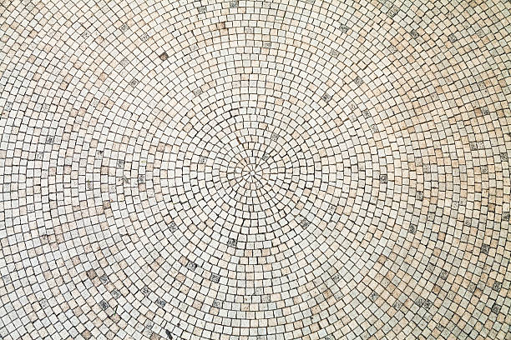

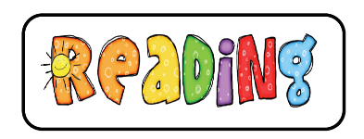

Week 1 | Week 2 | Week 3 | Week 4
Flashback: To make comparisons about similar books that have been read previously.  To retrieve and record information from a fiction text.  ? | Flashback: To retrieve and record information from a fiction text.  To use dictionaries to check the meaning of words that they read. | Flashbacks: To begin to use a dictionary to check and explain the meaning of unfamiliar words in context.  To predict what might happen from details stated and implied. | Flashbacks: To begin to make predictions that are supported by evidence from what they have read so far.  To make inferences such as inferring characters’ feelings, thoughts, and motives from their actions which they justify with evidence from the text.
Week 5 | Week 6 | Week 7 | 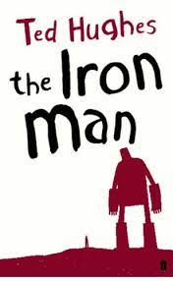
Flashbacks: To begin to make simple inferences by drawing on the actions of a character.  To discuss words and phrases that capture the reader’s interest and imagination.? | To identify how language, structure and presentation contribute to meaning. | To retrieve and record information from a non-fiction text.
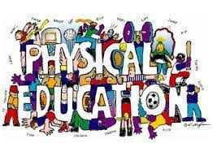
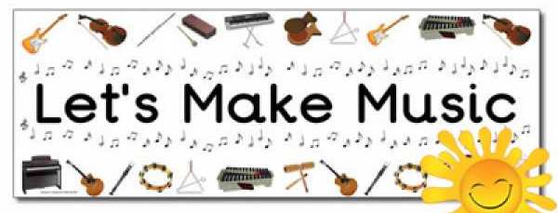
Year 3
Autumn Term 1
PHSE
Week 1: Strategies to manage transitions between classes and key stages
Week 2: About some of the skills that will help them in their future careers e.g. teamwork, communication and negotiation
Week 3: The importance of seeking support if feeling lonely or excluded
Week 4: About diversity: what it means; the benefits of living in a diverse community; about valuing diversity within communities
Week 5: To recognise reasons for rules and laws; consequences of not adhering to rules and laws
Week 6: About respecting the differences and similarities between people and recognising what they have in common with others e.g. physically, in personality or background

Netball
Lesson 1: To learn the three types of passes in netball.
Lesson 2: To learn the three types of passes in netball and execute with increased accuracy.
Lesson 3: To be able to use one of the three netball passes to get around an opponent.
Lesson 4: To be able to shoot a netball into the hoop.
Lesson 5: To be able to shoot a netball into the hoop with increasing accuracy.
Basketball
Lesson 6: To be able to pass and catch with a teammate.
Lesson 7: To be able to receive the ball effectively whilst on the move.
Lesson 1: To explain how digital devices function.
Lesson 2: To identify input and output devices.
Lesson 3: To recognise how digital devices can change the way we work.
Lesson 4: To explain how a computer network can be used to share information.
Lesson 5: To explore how digital devices can be connected.
Lesson 6: To recognise the physical components of a network.

Computing
Lesson 1: To explain how digital devices function.
Lesson 2: To identify input and output devices.
Lesson 3: To recognise how digital devices can change the way we work.
Lesson 4: To explain how a computer network can be used to share information.
Lesson 5: To explore how digital devices can be connected.
Lesson 6: To recognise the physical components of a network.

Languages
Lesson 1: I can say greetings in German
Lesson 2: I can say my name in German
Lesson 3: I can say some numbers between 1 and 10
Lesson 4: I can recall numbers to 10
Lesson 5: I can say 4 different colours in German
Lesson 6: I can recall colours
Lesson 7: Consolidation

Lesson 1: To be able to use dot notation to show higher and lower /Use tuned percussion.
Lesson 2: To be untraduced to staves, lines & spaces, and clefs/ To link pitch knowledge to musical notation (do-do)
Include a recap on rhythm notation
Lesson 3: To begin to play recorders / Blowing and hygiene
Lesson 4: To begin to play recorders / B, A – include staff notation
Lesson 5: To begin to play recorders /Recap B, A and introduce G, F
Lesson 6:To begin to play recorders / Recap B, A, G, F and introduce E, D
Lesson 7: To begin to play recorders/ Recap all notes.

