Intent:
Assessment
Wrekin View Primary School
2021 – 2022

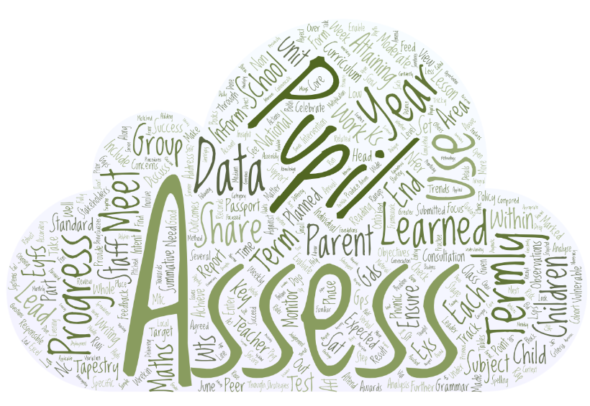

Happy, Successful, Curious, Communicators

At Wrekin View it is our intention to ensure that all children make progress within their year group in every area of the curriculum through several robust assessment systems. These systems are used to track each child’s progress against national expectations as well as supporting teachers in delivering lessons specifically targeted to areas which a child may find tricky. We communicate progress to the child and to parents through termly reports & termly parent’s evening. We have high expectations for all pupils’ no matter of their starting point, and we ensure that we help every child succeed in every subject. No matter how small the step forward, we celebrate their success and challenge them further.

Roles and Responsibilities:
Teachers and LSPs are responsible for carrying out both formative and summative assessments with individual pupils, groups and whole classes. Where appropriate, these outcomes will be shared with the pupils as part of an ongoing dialogue about their learning progress. Outcomes are also shared with parents at parental consultation meetings and within Annual Pupil Reports.

The Assessment Lead (Deputy Head Teacher) is responsible for:
- Monitoring standards
- Analysing pupil progress and attainment, including pupils and vulnerable groups
- Identifying vulnerable pupils at risk of under achievement
- Prioritising key actions to address under achievement, including the deployment of staff
- Reporting to all stakeholders
- Holding staff to account for pupil progress
- Target setting for the school, cohorts, groups and individual pupils

Assistant Head Teachers are responsible for:
- Monitoring standards in their subject according to standards set out in the EYFS Statutory Framework and Birth to 5 Matters or National Curriculum
- Interrogating the analysis of pupil progress and attainment, including pupils and vulnerable groups in their phases
- Ensuring all staff are familiar with assessment policy, practise and expectations

Subject Leaders are responsible for:
- Monitoring standards in their subject according to standards set out in the EYFS Statutory Framework and Birth to 5 Matters or National Curriculum

Class Teacher is responsible for:
- Planning in the short and medium term to meet the needs of all pupils
- Marking all work in line with the school policy
- Make several observations using Tapestry (see policy) for all children, across a range of lessons, across a unit of foundations subjects
- Each unit of Writing is assessed using (B, WTS, EXS, GDS) and discussed with children to see success and to set targets

Category | Description
GDS | Working at Greater Depth. Has a secure knowledge of the curriculum and can confidently work above the expected level in a wide range of context.
EXS | Working securely at Expected Standard for the year group that they are in.
WTS | Working Towards the expected standard for the year group that they are in.
B | Working below the expected standard for the year group that they are in.

- Each unit of Maths is assessed using White Rose Maths ‘End of Block Assessment’
- Ensuring that marking includes ongoing feedback to whole class and individuals to inform the children of success, next steps in learning and to address gaps in learning
- Enable children to assess their own learning and that of their peers
- Undertaking summative testing to inform teacher judgement (NFER, KS1, KS2 SAT, Y1 phonic assessment, Y4 Multiplication Tables Check)
- Analysis of summative testing is completed to inform subsequent planning
- Report data to Assessment Lead via excel spreadsheet, to be then updated on Insight
- Planning intervention to address learning needs
- Take part in pupil progress meetings to inform assessment lead of progress over time, set targets, ensure all vulnerable groups are adequately supported and discuss interventions to narrow gaps

Target Setting
At Wrekin view we set targets each Autumn Term and base our Targets on FFT 50 which is the benchmark for average progress. The proposed target is considered for each child by the Assessment Lead & HT based on FFT, KS1 SAT, internal NFER data and Teacher Assessment. The target could be adjusted to be more ambitious and to challenge the child or lowered to consider the individual child.
Targets are shared with children by the class teacher and then shared with parents via the Autumn Term Learning Passport. We aim for all children to achieve or surpass their target and put in place systems and support throughout the academic year to check progress.

Key features of Assessment at Wrekin View Primary School

Assessment for Learning (AfL)
Assessment for learning is a formative assessment that is integral part of teaching and learning. It is based on how well pupils achieve learning objectives, and providing feedback to involve the pupils in improving their learning. Strategies used in school:
- Planning – good planning ensures that there are clear learning objectives, matched to differing needs of the pupils and pitched using the National Curriculum. Questioning is planned into each lesson.
- Sharing learning objectives and success criteria with pupils – the children are fully involved in understanding the purpose of their learning and what they need to do to succeed
- Low Stakes Quizzes – These will be done periodically such as weekly, monthly, in the middle of a unit of work or at the end of a unit, to ensure that previously learned material is not forgotten.
- Diagnostic Questions is a form of this that form part of each Maths lesson. It is a method of assessment that has low threat to all children and AfL can be made by class teacher.
- Peer and self-assessment – pupils are taught how to and given time to evaluate their own and their peers’ achievements against the learning objectives and success criteria. Sometimes this will be in a written form. At others it will be verbally.
- Marking and feedback – all pupil’s work is marked in accordance to the marking policy. The feedback is verbal, with the child, and within a lesson so that the child can act immediately on the feedback. Distance marking will inform the teacher how to move the learning on, children success, where to direct support and if the planning needs modifying.
- Celebrating Achievement – all aspects of achievement are celebrated within school in a variety of ways. Dojo points are awards, weekly star of the week assembly shares the good work, Starbooks award, end of half term Dojo VIP and dojo badges are awarded and termly Dolphin Assembly celebrates children who have gone above and beyond.

Summative Assessment
Summative assessment takes a snapshot of learning which establishes what a child can do at a given time. These strategies are used in school:
- Statutory Assessments – pupils are assessed at the end of Key Stage 1 and Key Stage 2 through National Tests. These provide a summative end of key stage attainment result, and can be compared to national outcomes.
Pupils in Reception are assessed on entry using statutory baseline assessment.
Pupils in Year 1 are assessed in June using the Phonic Screening Check.
Pupils in Year 4 are assessed in June using the Multiplication Check.
This data is shared with the Local Authority at the end of the school year.
- Non-statutory assessment – commercially produced assessment tests (NFER) are administered each term to evaluate attainment against year group expectations in the national curriculum. Data from these assessments are shared with children and parents in the termly Learning Passport.

Tracking and recording attainment and progress
EYFS
- Prior to entry into EYFS, staff have discussions with feeder settings, parents Early Years Advisory SENCO.
- Daily meeting on focussed children
- Termly data submitted across 17 areas (B, WTS, EXS, GDS)
- Progress and attainment shared with stakeholders
- RWI assessment every 6-8 weeks
- Termly parent consultation
- Termly Learning Passport
- EYFS/KS1 phase leader to review attainment and progress across the phase
- Termly Pupil Progress Meeting

Year 1
- Pupils assessed across the NC in all areas of the curriculum using Tapestry
- RWI assessment every 6 – 8 weeks
- Termly NFER assessments (Maths, Reading, Grammar)
- Termly data submitted (W, R, M, GPS) (B, WTS, EXS, GDS)
- Tapestry Observations (non-core subject)
- Progress and attainment shared with stakeholders
- Termly phonic check assessment
- Termly parent consultation
- Termly Learning Passport
- Termly Pupil Progress meeting

Year 2
- Pupils assessed across the NC in all areas of the curriculum using Tapestry
- RWI assessment every 6 – 8 weeks
- End of unit writing assessment
- Termly NFER assessments (Maths, Reading, Grammar) & previous KS1 SAT tests
- Termly data submitted (W, R, M, GPS) (B, WTS, EXS, GDS)
- Tapestry Observations (non-core subject)
- Progress and attainment shared with stakeholders
- End of KS1 SAT
- Termly parent consultation
- Termly Learning Passport

Year 3, 4, 5
- Pupils assessed across the NC in all areas of the curriculum using Tapestry
- End of unit writing assessment
- Weekly spelling assessment
- Termly NFER assessments (Maths, Reading, Grammar)
- Termly data submitted (W, R, M, GPS) (B, WTS, EXS, GDS)
- Tapestry Observations (non-core subject)
- Progress and attainment shared with stakeholders
- Year 4 Multiplication Check
- Termly parent consultation
- Termly Learning Passport

Year 6
- Pupils assessed across the NC in all areas of the curriculum using Tapestry
- End of unit writing assessment
- Weekly spelling assessment
- Termly NFER assessments (Maths, Reading, Grammar)
- Termly data submitted (W, R, M, GPS) (B, WTS, EXS, GDS)
- Tapestry Observations (non-core subject)
- Progress and attainment shared with stakeholders
- End of Key Stage 2 SAT (Reading, Maths, Grammar)
- Termly parent consultation
- Termly Learning Passport

Pupil Progress Meetings
Pupil progress meetings are designed so that the progress of individuals and groups can be discussed with the Assessment Lead This enables staff to share approaches to supporting pupils learning, but also ensures accountability for attainment and progress. Following the meeting, staff adapt and amend planning, intervention groups, address concerns about individual pupils or pupils within vulnerable groups (B, G, FSM, PPG, SEND, EAL).

Tracking
All staff enter data onto an excel spreadsheet by 9am on Monday after each Assessment Week.
Subject Lead to enter data onto Insight Assessment Tracking and use data entered to run reports to show attainment and progress of each cohort. This is analysed for trends and concerns across school and used as a basis of Pupil Progress Meetings. Maths Lead, Writing Lead, Reading Lead, EYFS Lead and SEND Lead to analyse the data for their subject. Within the data analysis there is a focus upon:
- Gender variation in attainment or progress
- Children in receipt of PPG funding
- Children in Care
- Service children
- Children with SEN
- Higher attaining pupils
- Pupils with different Ethnic backgrounds
Monitoring
Termly Deep Dive methodology will monitor whether agreed assessment procedures are being consistently applied. Assessment Lead will meet weekly with intervention adults to discuss progress, evidence of progress, support materials and issues that have arisen.
Moderation
- In school moderation is part of the RAP. Within phase and year group, staff bring along a sample of work for an agreed subject and judgements are discussed. This can include creating a portfolio of samples of agreed expected standards.
- SDG moderation. Each term there is a subject focus for our group of schools to moderate Maths, Writing, Reading & EYFS. This is led by an advisor and split for specific year groups at points in the term.
- LA Moderation Termly meetings are attended by subject leads. The school EYFS lead attend moderation meetings. Staff in Year 2 and Year 6 attend moderation meetings for writing. On a cycle within the LA, the school will be selected for moderation of SATs or EYFS.
Evaluation of data
Termly data is scrutinised by Assessment Lead and shared with SLT. Trends and concerns are evaluated and feed RAP. This information is shared with Governors through the Head’s Report each term. At the end of the year, the data from SATs, along with Y4 MTC, Phonics data, EYFS GLD results and internal tracking data across school is used by the SLT to evaluate school strengths and areas for development. These, along with other monitoring, will feed into the RAP for the subsequent year.

Parental Consultation
Parent Conversation Meetings take place each term. They are used to share information about attainment in relation to age related objectives, and compared to national, progress a pupil has made, and their effort in learning. Parents are able to view pupils work and classroom, look at pupil target sheets within books and share test results as applicable. In Summer Term, following the Annual Report to Parents, there is a less formal open evening to view work from the year and talk to staff. If a more specific meeting is required, this can be booked with staff.
Through the year, all staff are available for more informal meetings to discuss progress concerns or any other aspect of learning. These may be called by staff or parents. There are informal opportunities to share in learning during each term, through open afternoon sessions, or opportunities to share in lessons.
Each term class teachers produce a termly Learning Passport that details each child’s data from summative assessment. In the summer term, there will be Learning Passport the details the levels for all subjects taught on the National Curriculum. End of Key Stage SAT results, Phonics tests in Year 1 or retakes in Year 2, Y4 MTC, EYFS attainment and attendance records are also included.

